Multimedia Lab

Assignment-1

NAME-Dipan Mondal

Roll-002211001112

Install The adobe photoshop.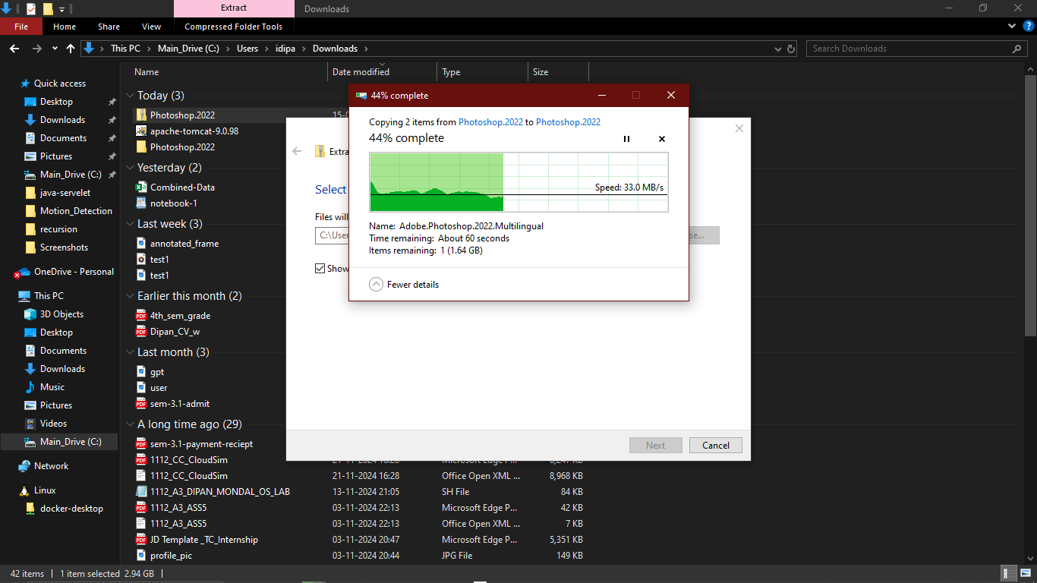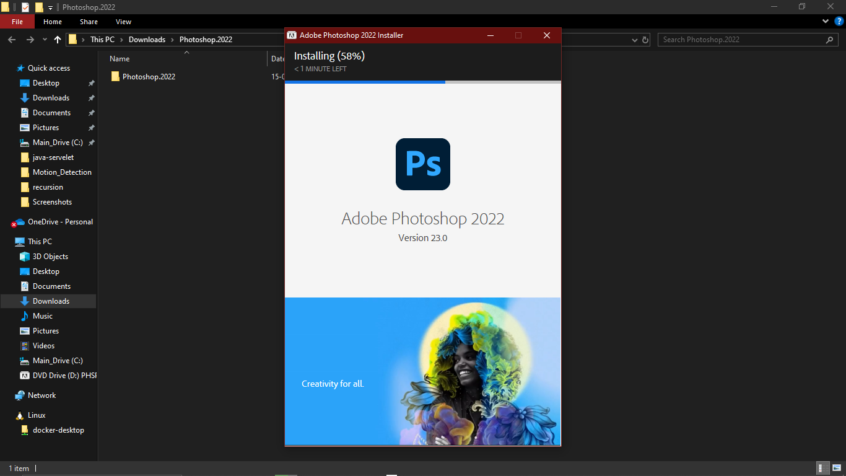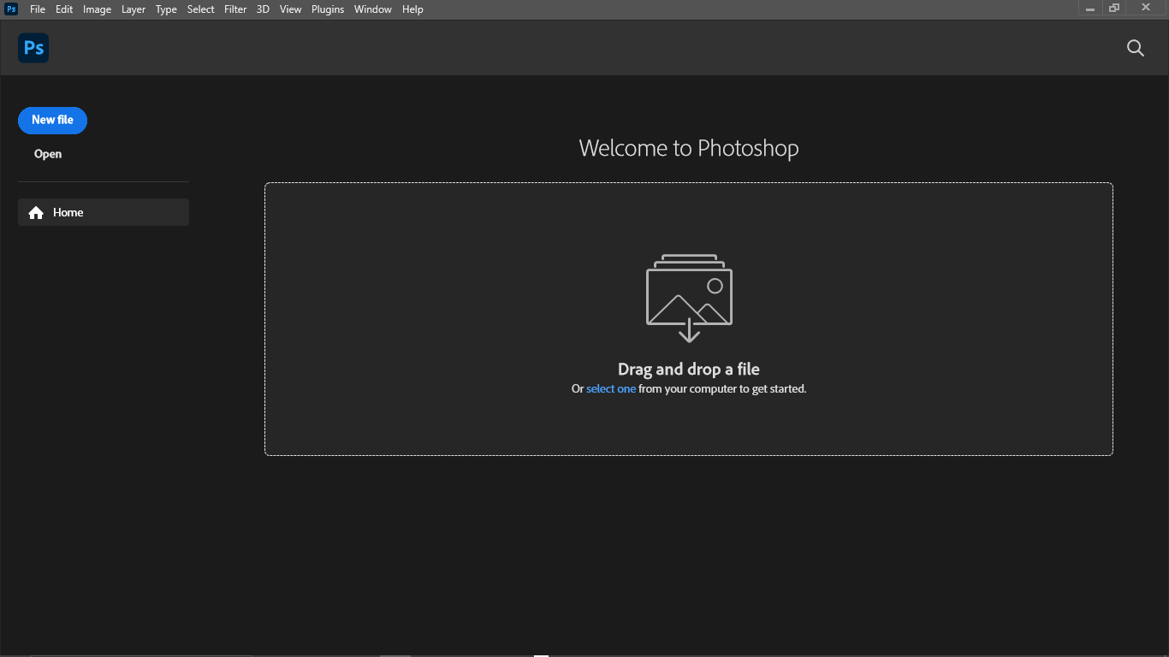

At First I download The Image “hydrant.tif” from the Assignment:

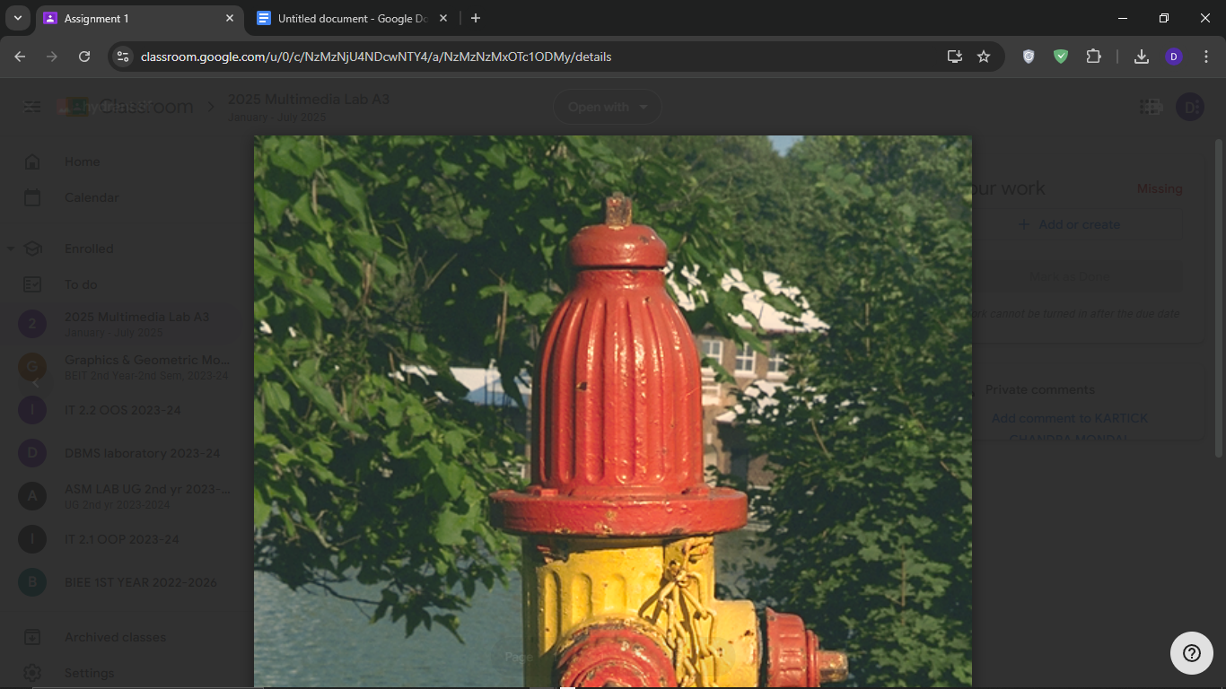

**Open File:**

Then Select File-> Open..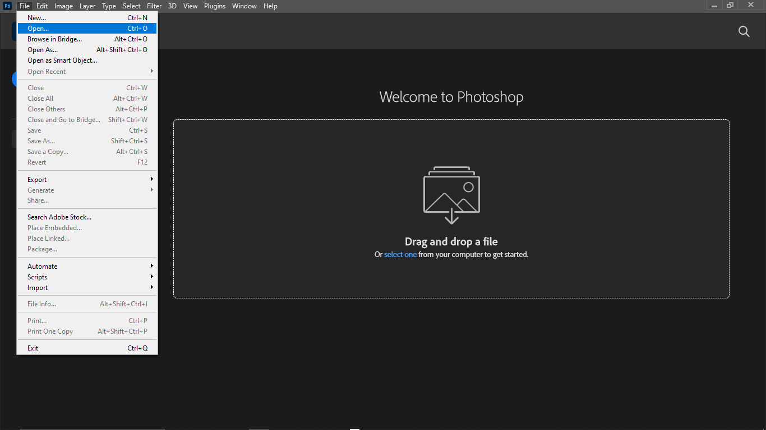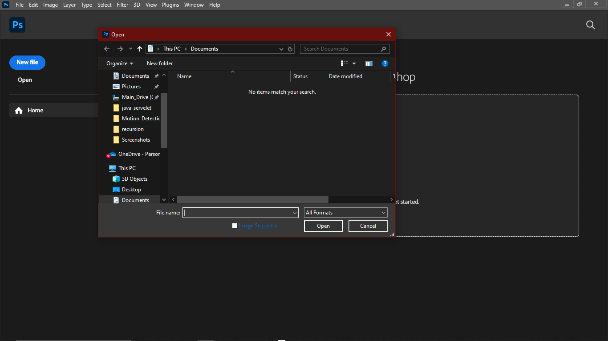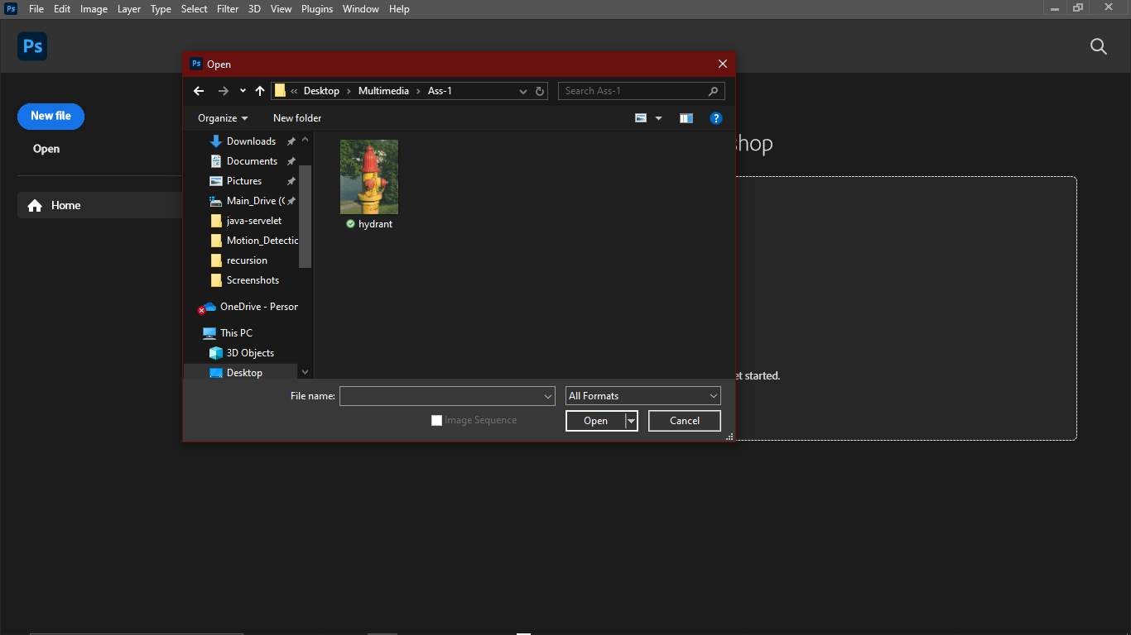

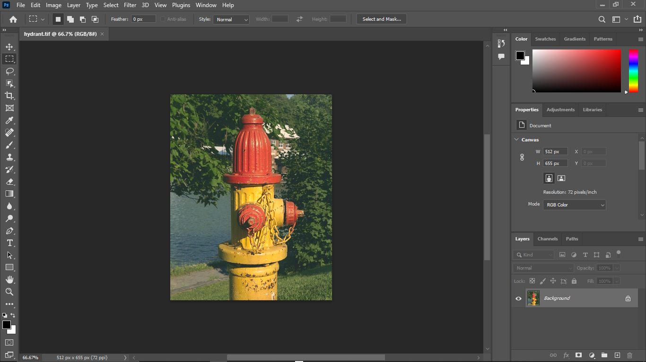

**Zoom:**

**Using Zoom tool clicked on hydrant head to zoom to 200%**



**Select(ML):**

**Now Select The Magnetic Lasso Tool**

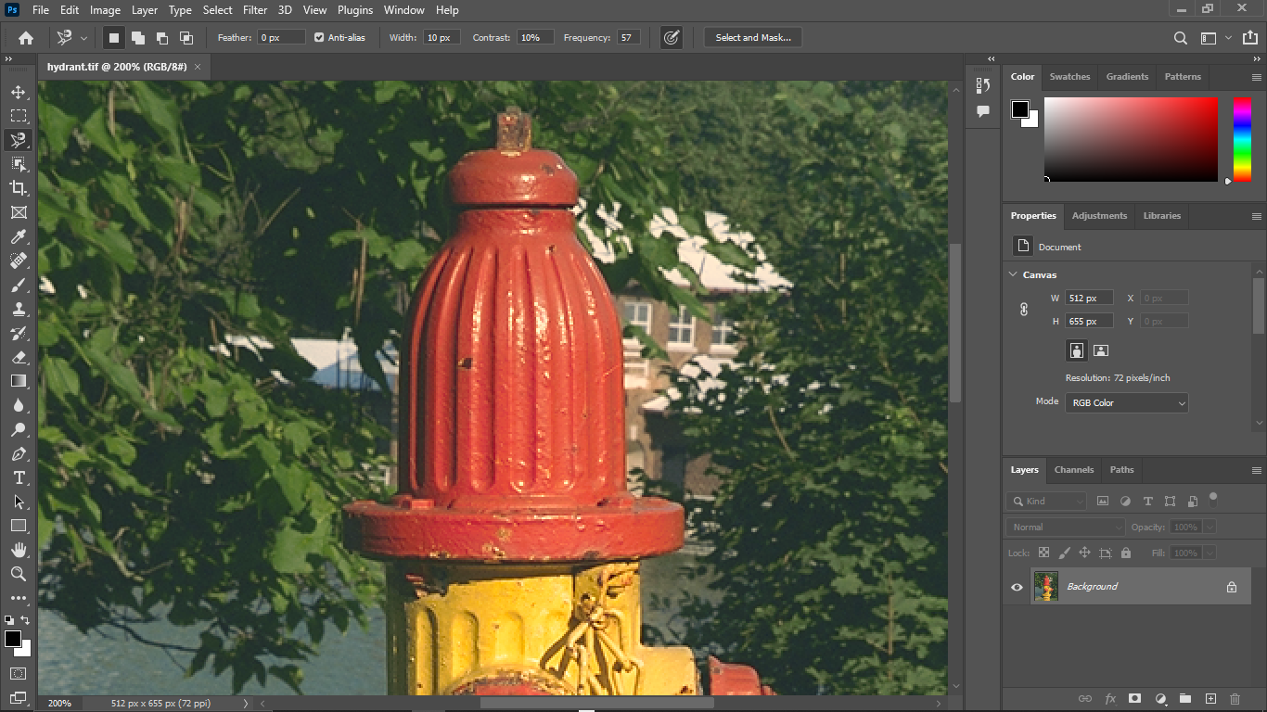

**Set Width 1px and contrast 100%**

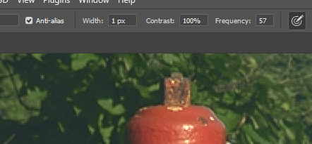

**Save Selection:**

**Move the tool along the border of the head to make selection**

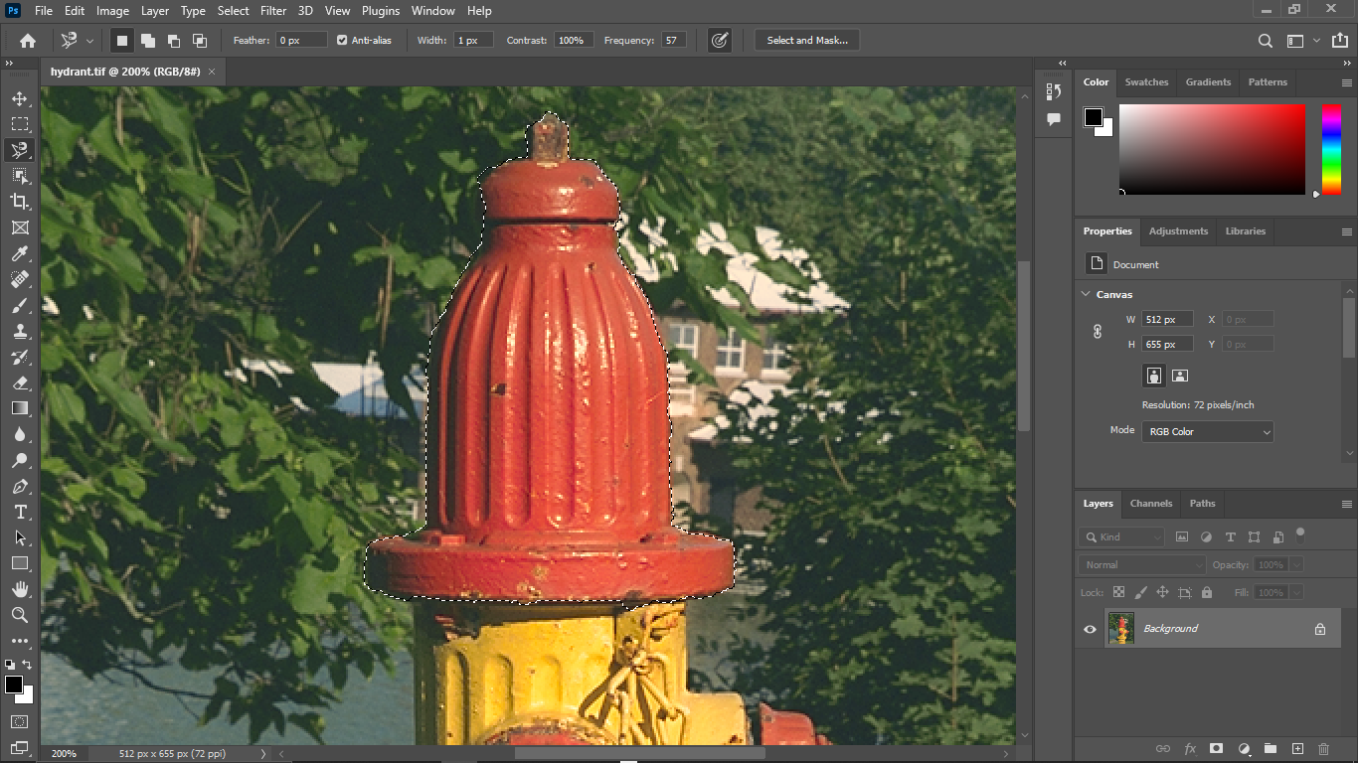

**Create Adjustment Layer:**

**New Adjustment Layer Created**

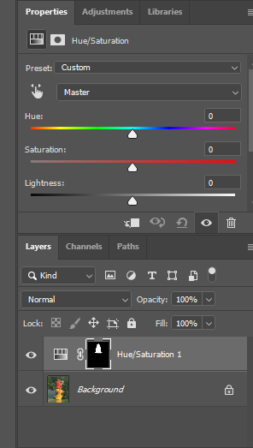

**Select The Hue/Saturation Option:**

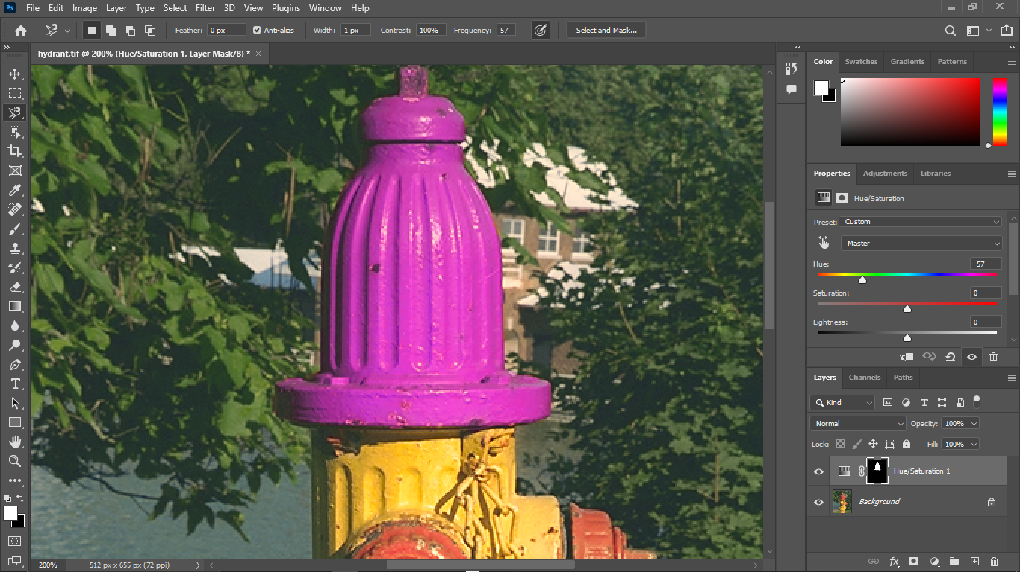

**One more color:**

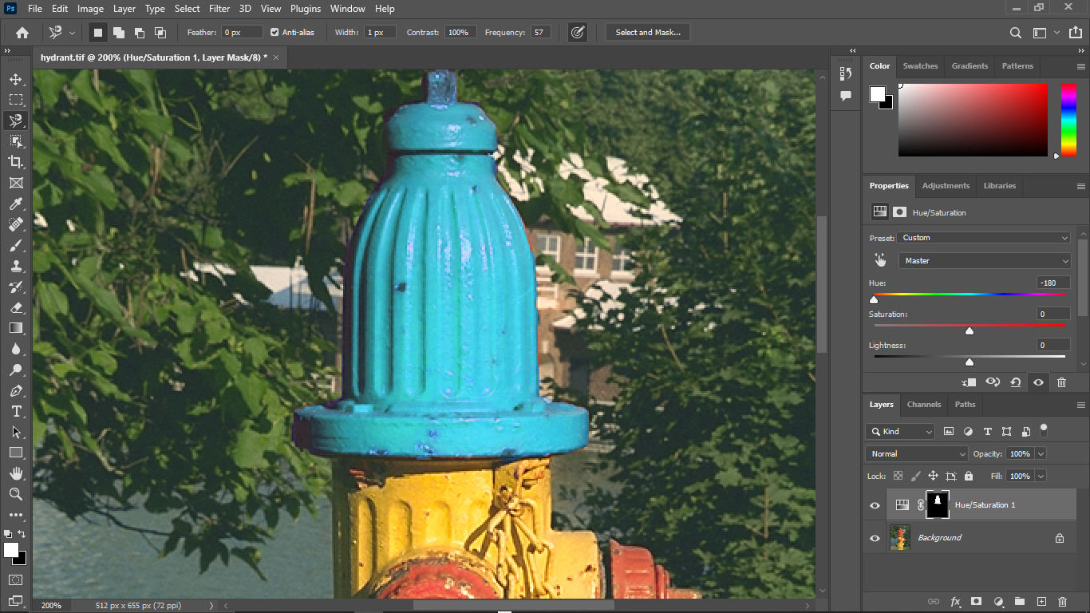

**Load Selection:**

**Choose Select**

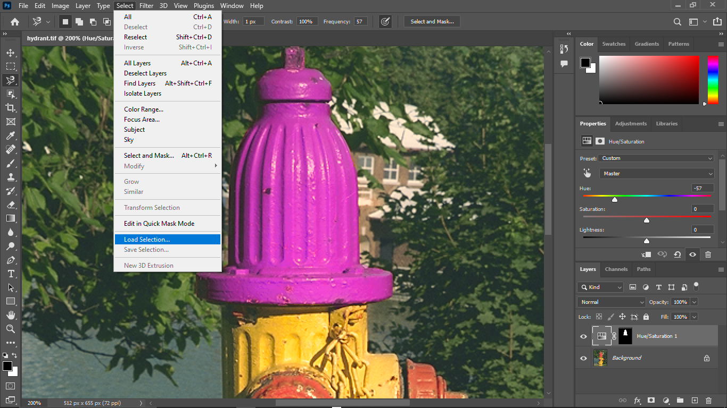

**Now Load selection and specify the name by “HEAD”**

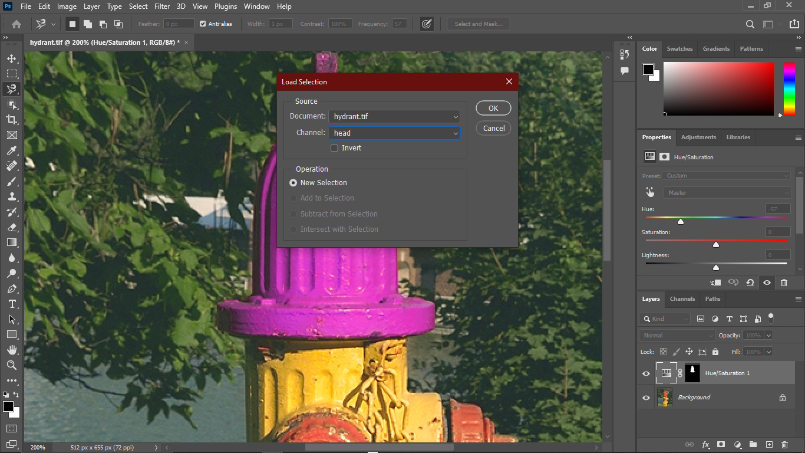

**Create Fill Layer & Change The Blending Mode:**

Creating a new fill layer by choosing - Layer>New Fill Layer> Pattern

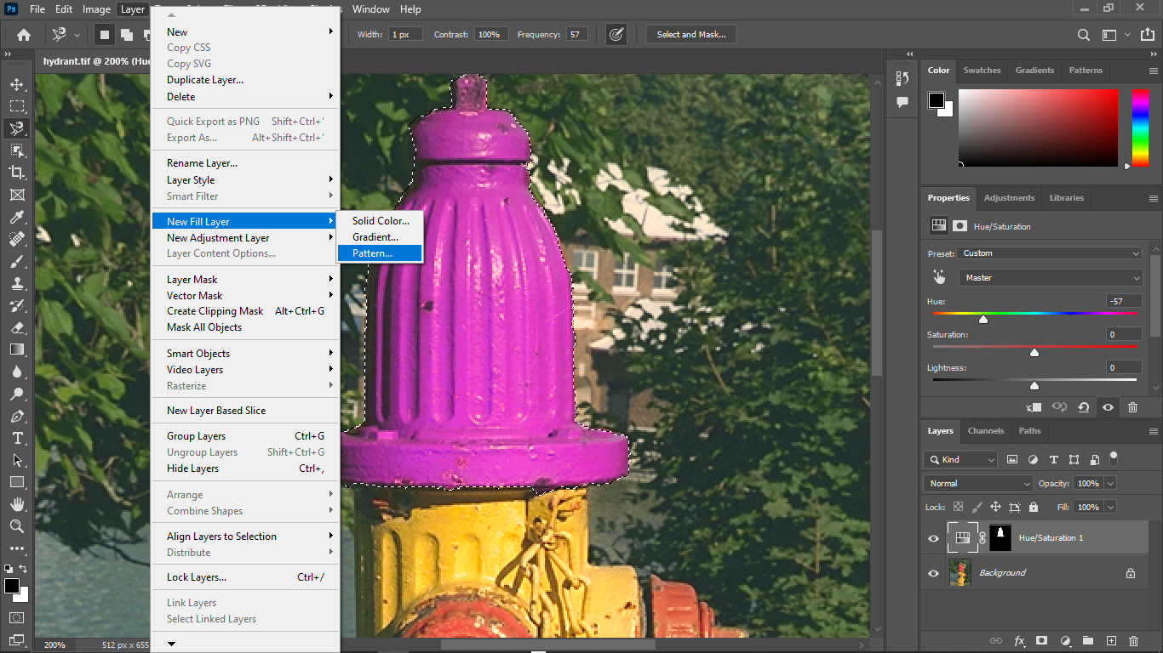

New Layer Created:

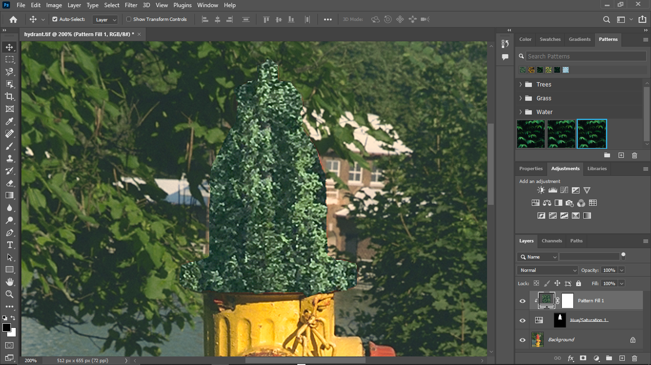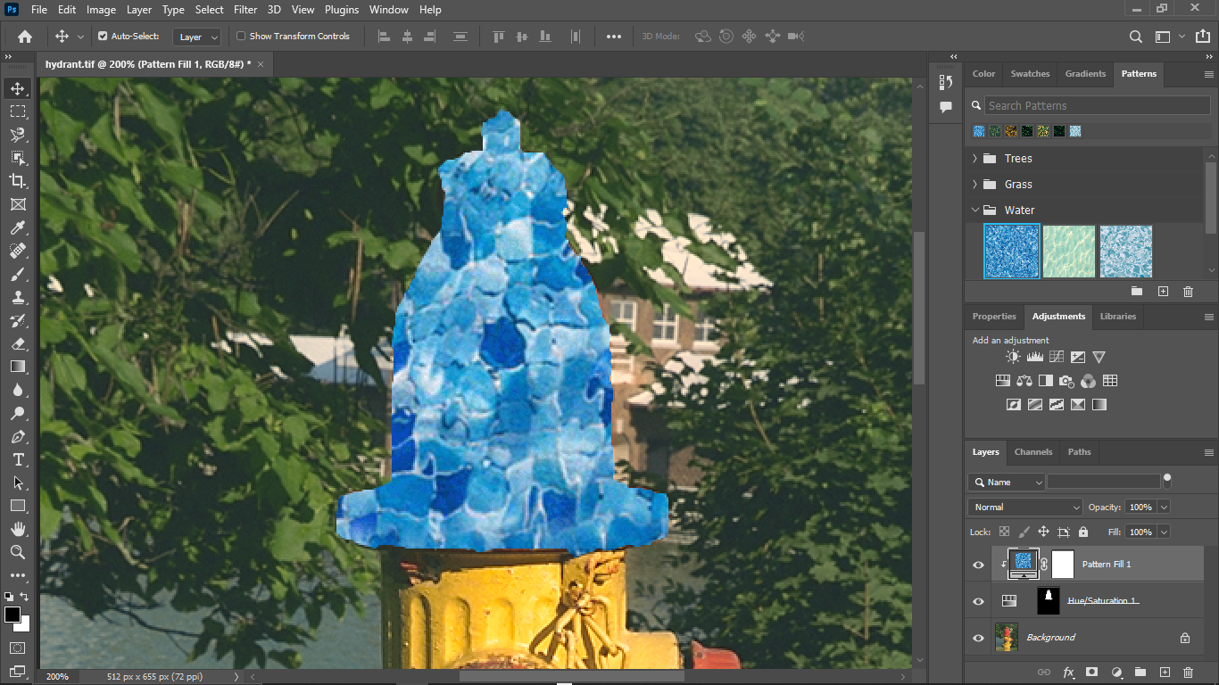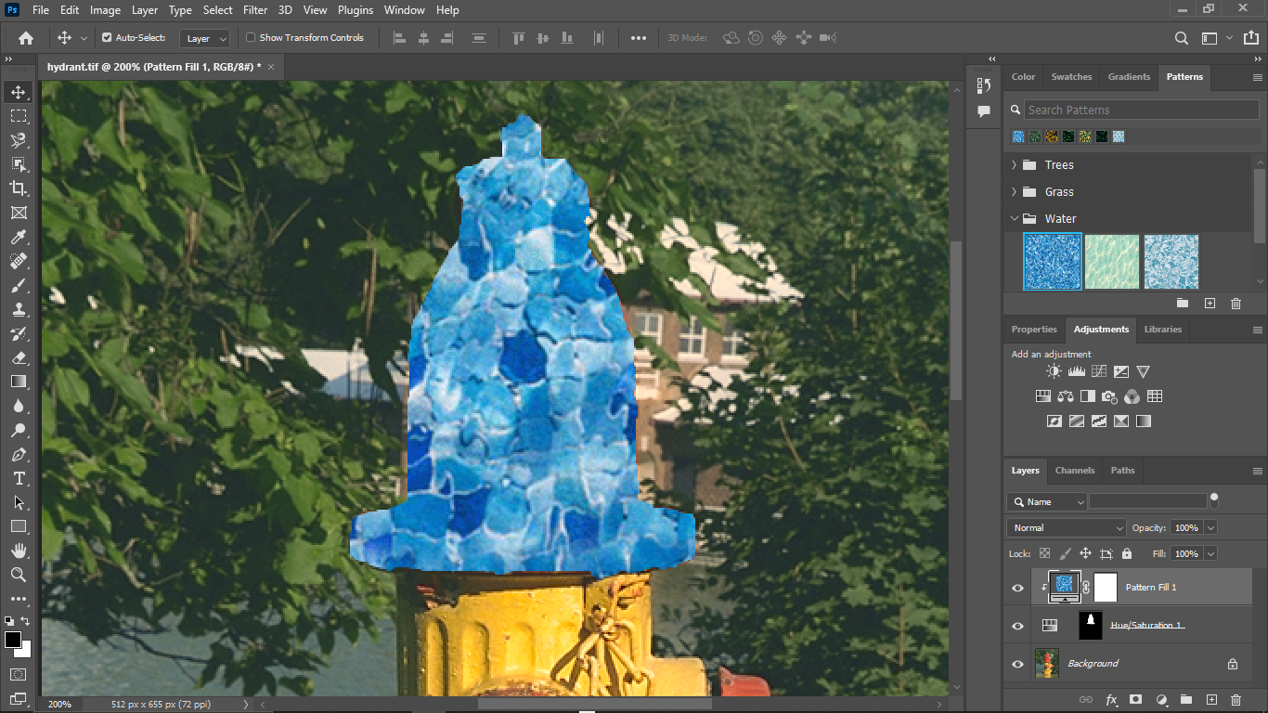

**Pattern Chossed:**

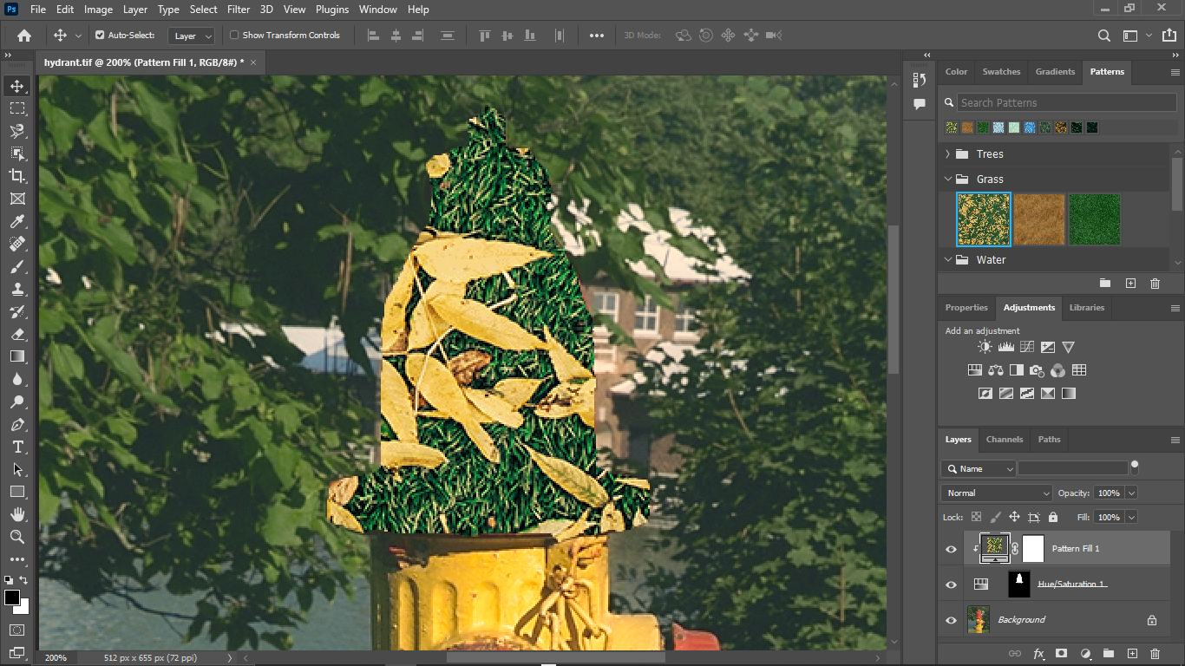

**Blending Mode Changed to overlay:**

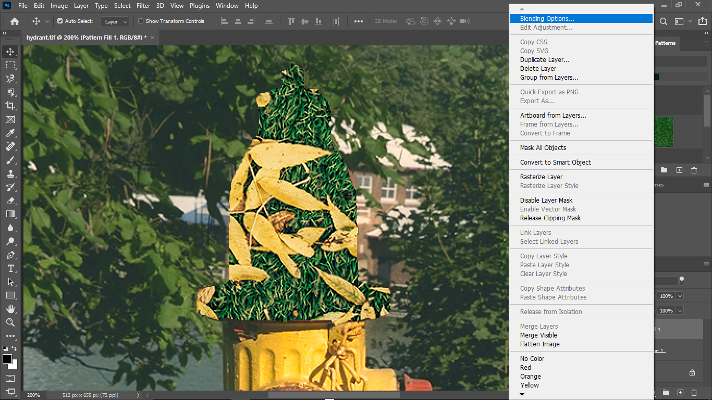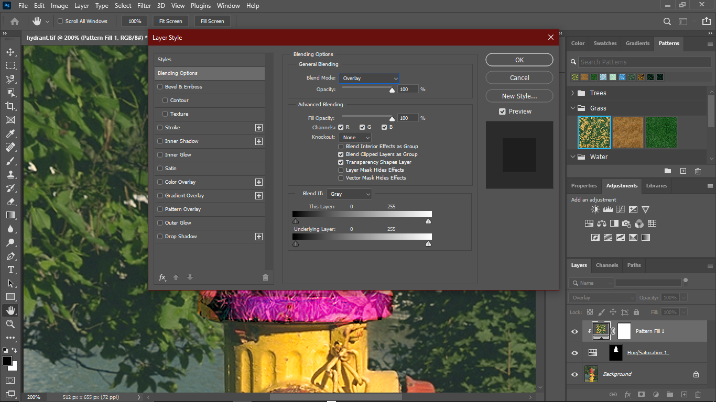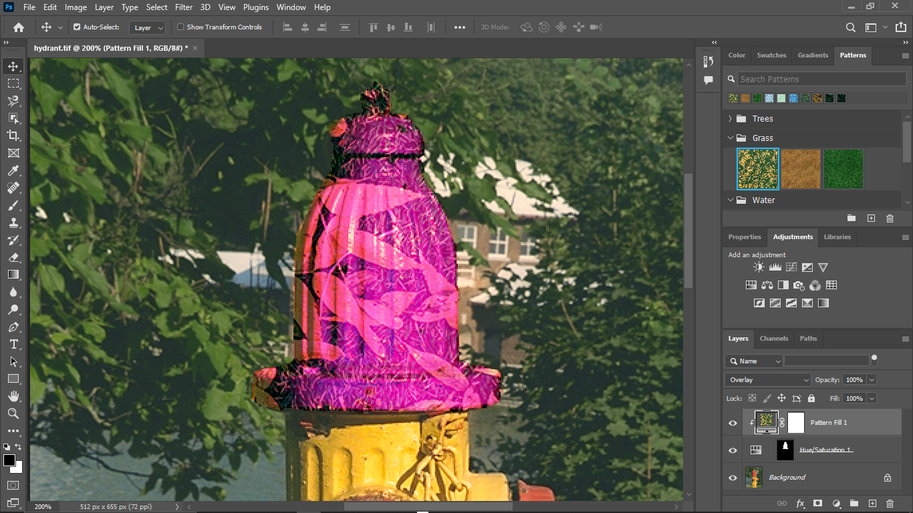

**Saving the file:**

